Canterbury High School News & Upcoming Events

80 Main Street, Canterbury, NB. E6H 1L3

Admin: Susan Mabie, Jeff Tompkins Phone: 279-Website: http://web1.nbed.nb.ca/sites/district14/chs
January  21-25 Exam Week Grades 9-12  22- Gr. 6-8 Field Trip (Chapters & Sleigh ride)  24 – Welcome to Kindergarten from 2:00 -3:00 pm  with family member/adult (free gift)  28- No School K-12 – Staff PL day  29 – No School grades 9-12 only  Turn Around Day  30 – First Day semester 2  Parents/Families: Please come in with your child if you have questions about credits or course changes.  31 – Report Cards 9-12  February  11 – Crabbe Mountain or Ayr Motor trip (swim/field house) grades 6-12  18 No School – Family Day  20 Gr. 3-5 Field Trip (Chapters & Sleigh Ride)  March  4-8th – March Break  22 – No School – PL day for staff | Students of the Month for November  K- Maria Crewe 7-8 –Markie McLaughlin  1-2 –Keaton Irwin 9- Gracie Rees  3-4 –Trinity MacKinnon-Whiffen  10-Lydia Dickinson  5- Kayser McLaughlin 11- Jacob Lawson  6- Marla Bedard 12- Nathaniel Leeman  Students of the Month for December  K- Reid Dumas 7-8 –Savanna Walker  1-2 – Jack McKinney 9- Aly Dickison  3-4 – Quinn Webber 10- Jack Durling  5- Peyton Bell  6- Ava Watson 12- Logan Grant  ********************************************  Thank you to Sabian Employees for donating the money for Christmas Dinner & Serving as well as to the Culinary Arts Class for Preparing Dinner.  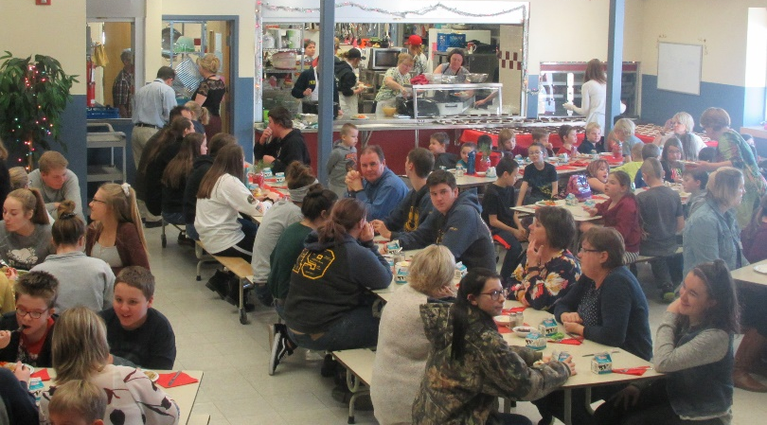  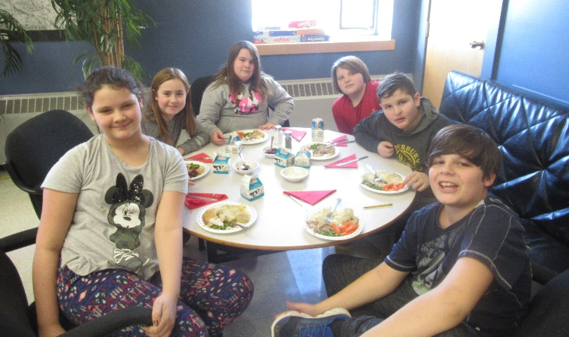  School Cash On-line: You are able to pay your school packs and school fees on-line, field trips, athletic fees and cafeteria cards. If you have not registered, please go to the School Cash Online home page at https://anglophonewest.schoolcashonline.com/ and select “Get Started Today” option.  Chatter High Competition Grade 10  Chatter High is online service promoting career exploration and post-secondary options for students. Canterbury High grade 10 PDCP won $515 for placing:  1st for NB “A” Schools  2nd Place Nationally for “A” Schools
Seniors’ Dinner & Visit
Our community seniors came to CHS December 19th to enjoy a turkey dinner prepared and served by culinary arts. We enjoyed having them join us and were pleased many were able to stay and watch the Christmas concert.
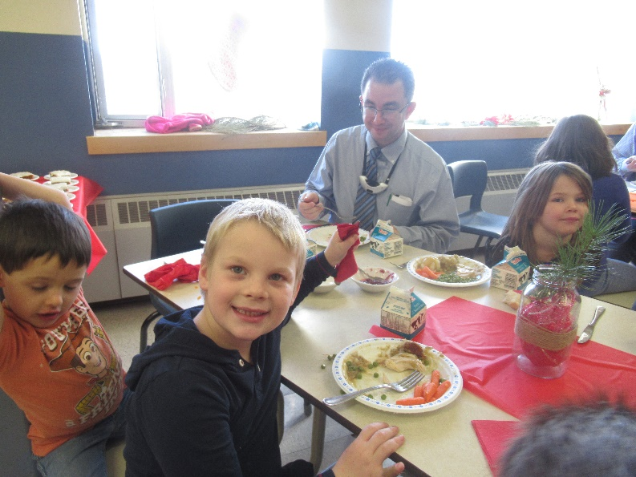
Christmas Dinner
January to March Cafeteria Menu 2019
7  No School | 8  Spaghetti & Garlic Bread | 9  Turkey Shepherd’s Pie | 10  Pulled Pork Sandwich & Potato Wedges | 11  Pizza Day
14  No Cafeteria | 15  Dressing Stuffed Chicken Breast, rice & veggies | 16  Baked Ham & Potato Scallop | 17  Fajitas & Potato Wedges | 18  Pizza Day
21  No Cafeteria | 22  No Cafeteria | 23  Lasagna & Garlic Bread | 24  Turkey Shepherd’s Pie & Garlic Bread | 25  Pizza Day
28  No School | 29  No Cafeteria | 30  Subs & Tomato Soup | 31  Spaghetti & Garlic Bread | February 1  Pizza Day
4  No Cafeteria | 5  No Cafeteria | 6  Tomato Soup & Grilled Cheese | 7  Subs & Potato Wedges | 8  Pizza Day
11  No Cafeteria | 12  Tomato Soup & Grilled Cheese | 13  Barbeque Chicken, garlic whipped potatoes & veggie | 14  Spaghetti & Salad | 15  Pizza Day
18  No School Family Day | 19  No Cafeteria | 20  Subs & Homemade Chicken Soup | 21  Meatloaf, potatoes & Veggies | 22  Pizza Day
25  No Cafeteria | 26  Beef & Veggie Stir Fry served on rice | 27  Chili or Tomato soup & grilled cheese | 28  Chicken Fajitas & potato wedges or Mexican Rice | 1  Pizza Day
11  No Cafeteria | 12  Beef Tacos, Potato wedges, rice | 13  Orange Ginger Chicken, Veg & Rice | Hamburger 14  Maccaroni Soup or Chicken Casseole with Garlic Bread | 15  Pizza Day

Grades 9-12 Exam Schedule Jan. 21-25th 2019
 | Monday,  8:30-10:30 exam. | Tues., Jan. 22  8:30-10:30 exam. | Wednesday, Jan 23  Exam 9:00-11:00 | Thurs., Jan 24  Exam 9:00-11:00 | Fri., Jan 25
AM | Pre-Calculus 12B  Pre-Calculus 11  Workplace Math 110  Workplace Math 120  10 English  9 ELPA | English 113  English 112  English 123  English 122  10 Science  9 English Portfolios | 9 Science  10 Math  World Issues 120 (Portfolio)  Foundations Math 11 | Chemistry 112  History 10  9 Math  Human Phys. 110  Metals 110 & 120
 | Lunch 11:30-12:00 | Lunch 11:30-12:00 | Lunch 12:00-12:50 | Lunch 12:00-12:50
PM | Exam 12:00-2:00 ELPA Rewrite  9 Eng. Portfolio  Interviews | Exam 12:00-2:00 Biology 112  9 Soc. Studies
All exams are 2 hours and students will be given additional time up to 3 hours. In order to ensure all exams can be written in one week, Friday has no scheduled exam so we have a “back up” day in the event of a storm day. Doubling up and writing all exams prior to Friday was at the request of the district so on two days, there are two exams. Students on both days will still have 2 hours plus an additional hour even with a 30 minute lunch. Should there be a storm day, all days get pushed forward but do not change order. Ex. If Monday is storm then the Monday exams would be Tuesday, Tuesday exams would be on Wednesday, etc. A voice mail will also be sent should there be forecasted storm to be sure everyone is clear about the exam schedule. Students must remain in the exam room for two hours to encourage them to give their best effort and not rush.

